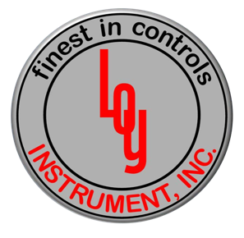
Dear Valued Customers,

I am pleased to announce that Loy Instrument, Inc is now the authorized Honeywell PMC Distributor for the State of MI. Loy Instrument is a Platinum Stocking Distributor with branch offices located in Fort Wayne IN, Cleveland OH, Cincinnati OH and headquarters in Indianapolis IN.

Loy Instrument was established in 1937 as a privately-owned organization serving the thermal process market. Their hands-on approach proved to be what their customers wanted back then, as well as today. Since that early beginning Loy Instrument has strived to understand the customer's processes to recommend the best solutions. A combined 600+ years of in-house process control and combustion experience gives our customers the benefit of working with a company that has in depth knowledge of processes and products. In addition to local stock Loy Instrument provides calibration services and engineered solutions to meet our customers needs.

From design assistance required by the largest heat treating and process customers to the single loop process control, Loy Instrument is ready to put their experience to work with a regional network sales engineers and service technicians based in the field where you need them, when you need them. These highly skilled professionals are some of the most knowledgeable and experienced resources in the process control and industrial combustion industry. Loyal customer support and recognition of our application expertise has defined Loy Instrument, Inc. as best in class.

Andy Foust – Channel Manager Honeywell Process Solutions
Cell +1.815 375-8435
Email: Andrew.Foust@Honeywell.com
Jeff Burger – VP Sales
Loy Instrument, Inc.
Cell +1.216 835-6112
Email: jburger@loy-instrument.com

Honeywell Internal

